The three NDIS budget categories
If you have a National Disability Insurance Scheme (NDIS) plan, you’ve probably noticed that the funding is broken up into three budgets, or ‘support purposes’ as they are known in NDIS speak. These are core, capital and capacity building.
But what does this actually mean?

Core supports
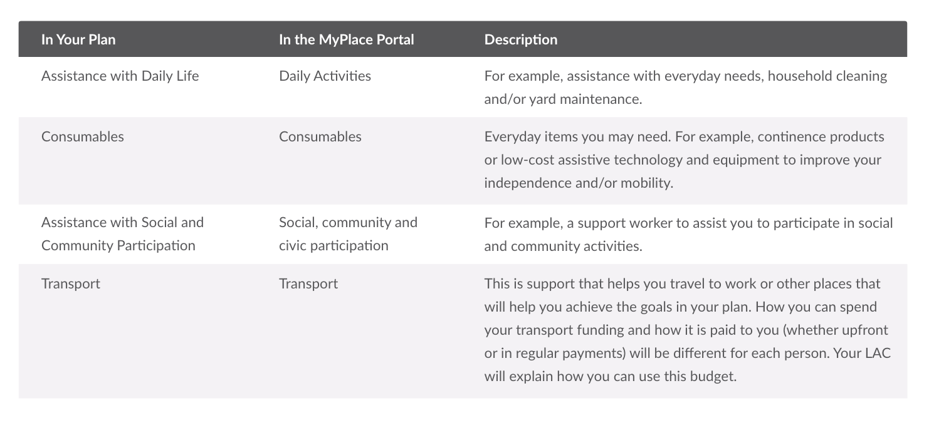

Capital supports
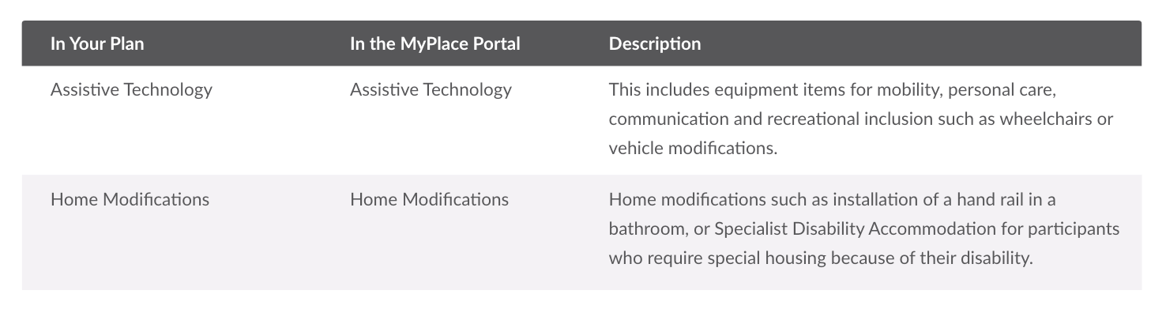

Capacity building supports
